
Department of Computer Science
BCS 3101: MACHINE LEARNING
Year 3 Semester 1
ASSIGNMENT 2
Predicting Monthly Maize and Beans Prices in Selected
Ugandan Markets Using Historical Price and Market Data
GitHub repo:
https://github.com/Allan12377/BCS3101-Assignment2-Maize-Beans-Prices
Group Members
No. | Names | Reg. No.
1 | AYEN GEOFFREY ALEXANDER | 2024/A/KCS/5102/G/F
2 | KUKUNDAKWE SAVIOUS | 2024/A/KCS/4333/F
3 | AINEBYONA ALLAN | 2024/A/KCS/1670/F
4 | KYOSHABIRE DIANAH | 2024/A/KCS/5188/G/F
5 | NIYONSHUTI MERCY | 2025/A/KCS/6117/F
6 | ARINDA ELIZABETH | 2024/A/KCS/3099/G/F
7 | GUMISIRIZA AMBROSE | 2024/A/KCS/3143/F

1. Title
Predicting Monthly Maize and Beans Prices in Selected Ugandan Markets Using Historical Price and Market Data.

2. Background
Food prices affect the daily live of many people in Uganda. Maize and beans are staple foods. When thier prices rise quickly, households, traders and aid organisations feel the effect. A model that can estimate future prices from past market data can support better planning.
This project treats the task as a regression problem. The goal is to predict the monthy price of maize and the monthly price of beans. The predictors include the month, the year, the market location, related food prices, inflation indicators and a few coverage scores.
The work folows the standard data mining pipelin of cleaning, integration, transformation and reduction. That pipeline sits inside the broader Knowledge Discovery in Databases process of turning raw data into useful insight [1], [2]. After the data were prepared, four different regression models were trained, compared and the best model was retained for prediction. The report shows each decision with numbers and charts taken from the project notebooks.

3. Data Description
The dataset is the Uganda Real-Time Food Prices (RTFP) series published by the World Bank Development Economics Data Group. The prices are collected from the World Food Programme and the Food and Agriculture Organization. Some missing market observations are filled by machine-learning estimates. The completed series begin with the prefix c_ [3].
We selected seven markets that give good geographc coverage and full monthly records from 2007 to 2026: Market Average, Gulu, Lira, Jinja, Hoima, Busia and Mbarara. After filtering, the working table contains 1 652 rows and more than 100 columns. The two target variables are c_maize and c_beans (completed monthly prices in Uganda shillings per kilogram).
The original observed price columns contain many missing values. The completed columns have zero missing values. This pattern is expected for an RTFP product that combins direct measurement with estimation.
Data in the real world is dirty. Han, Kamber and Pei note that real data is often incomplete, noisy or inconsistent. Incomplete data lacks attribute values. Noisy data contains errors or outlier. Inconsistent data contains discrepancies in codes or names [1]. The RTFP series shows both incomplete observed prices and completed estimates. This guided the choice of targets.
Table 1. Summary of the working dataset.
Item | Value
Source | World Bank RTFP (WFP / FAO)
Markets kept | 7 (Market Average, Gulu, Lira, Jinja, Hoima, Busia, Mbarara)
Rows after filter | 1652
Time span | January 2007 – August 2026
Main targets | c_maize, c_beans (UGX per kg)
Model-ready rows (after dropna) | 1344
Number of features used | 18 numeric features

4. Data Pre processing Techniques Applied
Major tasks in data preprocessing include data cleaning, data integration, data reduction, and data transformation and data discretization [1]. The group followed this order.

4.1 Data Cleaning
Data cleaning fills in missing values, smooths noisy data, identifies or removes outliers, and resolves inconsistencies [1]. Missing values were counted for every column. The completed targets c_maize and c_beans had zero misssing values, so they were kept as the regression targets. The original observed price columns had missing rates above 50 percent. Those columns were retained only for comparison and were not used as model features. Columns that were almost emptty, such as salt, were marked for removal during feature selection.
How to handle missing data is a standard question in the literature. One may ignore the tuple, fill the value manually, or fill it automatically with a global constant, the attribute mean, or the most probable value [1]. In this project the completed series already supplied the most probable estimates, so no further imputation of the targets was required.
Exact duplicate rows were checked with the duplicated method. No exact duplicates were found. Each market-month combination appears only once.
Outliers in the two targets were detected with the interquartile range rule of Tukey [4]. A number of high prices were flagged. These points appear across many years and match known periods of market stress. They were therefore retained as genuine observations rather than removed or capped. Han et al. note that noisy data may contain errors or outliers and that the decision to remove or keep them depends on domain knowledge [1].

4.2 Data Integration
Data integration is the integration of multiple databases, data cubes, or files [1]. Data integration was not applicable. The project uses a single unified source file. The companion guide states that an explicit statement of this kind is preferred to a silent omission [5].

4.3 Data Transformation
Data transformation includes normalization and concept hierarchy generation [1]. Market names are nominal categories. They were converted to binary indicator columns by one-hot encoding, with the first category dropped to avoid perfect collinearity. Year and month were kept as numeric features so that the models could capture long-term trend and seasonal effects. Latitude and longitude of each market were retained as continuous geographic predictors.
Feature scaling used the StandardScaler from scikit-learn. The mean and standard deviation were computed on the training portion only. The same statistics were then applied to the test portion. Scikit-learn documentation and common practice state that test data should never be used to make choices about the model and that the general rule is never to call fit on the test data [6], [7]. This order prevents information from the test set from leaking into the training process.

4.4 Data Reduction and Splitting
Data reduction includes dimensionality reduction and many reduction [1]. After encoding, the feature set contained 18 numeric columns: year, month, latitude, longitude, completed oil price, food-price index, inflation and trust scores for maize and beans, data-coverage scores, and the market dummy variables. Rows that still contained missing values in any of these features were dropped, leaving 1344 complete observations.
An 80 / 20 train-test split with a fixed random seed of 42 produced 1075 training rows and 269 test rows. The same indices were used for both maize and beans so that model comparsion remains consistent.
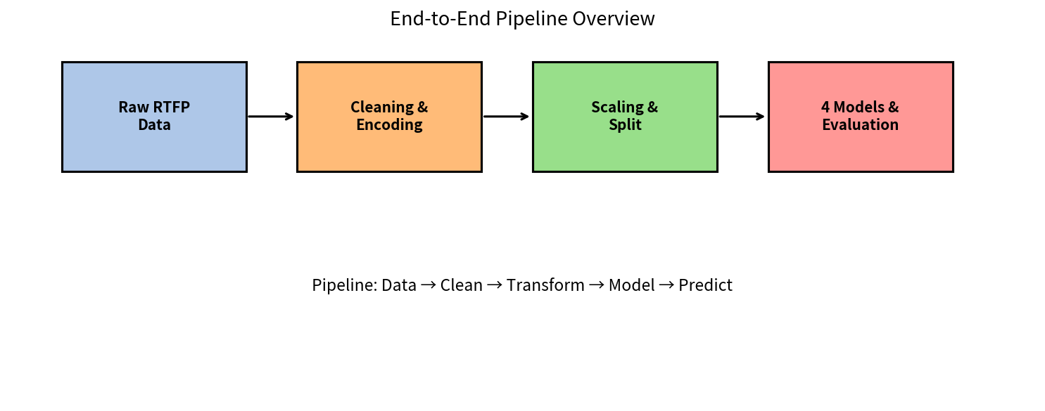
Figure 1. Overview of the end-to-end pipeline from raw data to model evaluation.
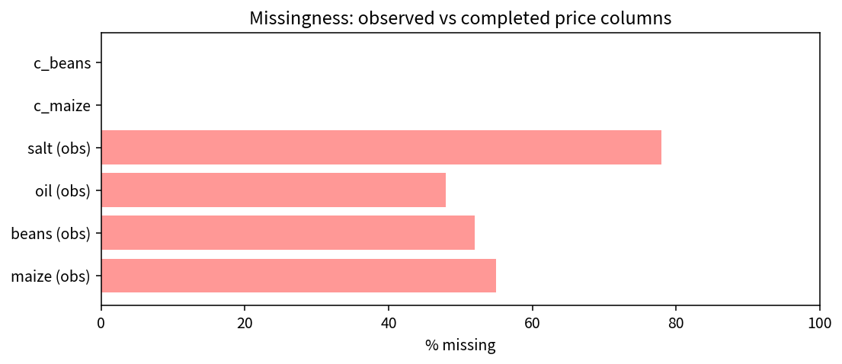
Figure 2. Percentage of missing values in observed versus completed price columns.
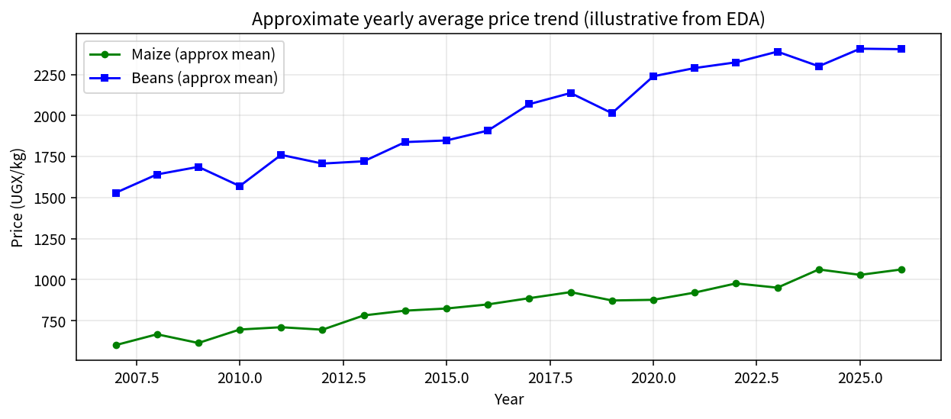
Figure 3. Approximate yearly average price trend for maize and beans (from EDA).
Percentage of missing values in observed versus completed price columns.
Figure 3. Approximate yearly average price trend for maize and beans (from EDA).

5. Summary of Exploratory Data Analysis
Exploratory data analysis examined the distributions of the two targets, the yearly trends, the correlation between maize and beans, and the missingness pattern of the original observed columns. Both targets are continuous and right skewed. A long term upward trendn is visible in the yearly average prices. The correlation between c_maize and c_beans is positive and strong. High-price points flagged by the interquartile-range rule appear in several different years and were kept.
The completed series used as targets have no missing values. This contrast guided the decision to rely on the completed prices for modelling. For modelling, mean absolute error is more robust than metrics that assume symmetric errors.

6. Model Development
Four genuinely different regression models were trained on the prepared data. The spread follows the recommendation for a regression problem in the course materials: a linear baseline, a regularised linear model, a single decision tree and an ensemble of trees.

6.1 Linear Regression
Ordinary least squares linear regression is the simplest baseline. It minimises the residual sum of squares. The model is easy to interpret and does not require hyper-parameter search.

6.2 Ridge Regression
In multiple regression it is shown that parameter estimates based on minimum residual sum of squares have a high probability of being unsatisfactory if the prediction vectors are not orthogonal. Ridge regression is an estimation procedure based on adding small positive quantities to the diagonal of X′X [8]. The ridge estimate used here has alpha equal to 1.0. The penalty reduces the influence of correlated predictors.

6.3 Decision Tree Regressor
A decision tree regressor partitions the feature space by recursive binary splits. The tree was limited to a maximum depth of 10 so that it does not grow without bound and over-fit the training sample.

6.4 Random Forest Regressor
Random forests are a combination of tree predictors such that each tree depends on the values of a random vector sampled independently and with the same distrbution for all trees in the forest. The generalization error for forests converges almost surely to a limit as the number of trees in the forest becomes large. The generalization error of a forest of tree predictors depends on the strength of the individual trees and the correlation between them [9]. The forest used here contains 100 trees, each limited to depth 10. The final prediction is the average of the individual trees. These ideas are also applicable to regression [9].

6.5 Training and evaluation procedure
Each model was fitted on the scaled training features. Predictions were generated on the held-out test set. Performance was measured by mean absolute error (MAE), root mean squared error (RMSE) and the coefficient of determination (R²). Five-fold cross-validation on the training data supplied the mean and standard deviation of the R² score, showing how stable each result is across different folds.

7. Results

7.1 Results for maize prices
Table 2. Comparison of the four models on the maize test set.
Model | MAE (UGX) | RMSE (UGX) | R² | CV R² mean ± std
Linear Regression | 143.8 | 193.3 | 0.841 | 0.828 ± 0.019
Ridge (α = 1.0) | 143.8 | 193.3 | 0.841 | 0.828 ± 0.019
Decision Tree (depth = 10) | 96.6 | 144.9 | 0.910 | 0.857 ± 0.012
Random Forest (n = 100) | 80.3 | 113.4 | 0.945 | 0.929 ± 0.006
Linear regression and ridge produce almost identical scores. The decision tree improves both the absolute error and the R² value. The random forest records the lowest MAE (80.3 UGX), the lowest RMSE (113.4 UGX) and the highest R² (0.945). Its cross-validation standard deviation is also the smallest, which shows that the improvement is stable.

7.2 Results for beans prices
Table 3. Comparison of the four models on the beans test set.
Model | MAE (UGX) | RMSE (UGX) | R² | CV R² mean ± std
Linear Regression | 270.8 | 363.7 | 0.885 | 0.884 ± 0.010
Ridge (α = 1.0) | 270.7 | 363.7 | 0.885 | 0.884 ± 0.010
Decision Tree (depth = 10) | 190.0 | 270.3 | 0.936 | 0.887 ± 0.021
Random Forest (n = 100) | 151.3 | 200.4 | 0.965 | 0.942 ± 0.012
The ranking of the four models is the same for beans. The random forest again leads with an R² of 0.965 and an MAE of 151.3 UGX. Because the absolute price level of beans is higher than that of maize, the absolute error numbers are larger, yet the relative ordering remains unchanged.
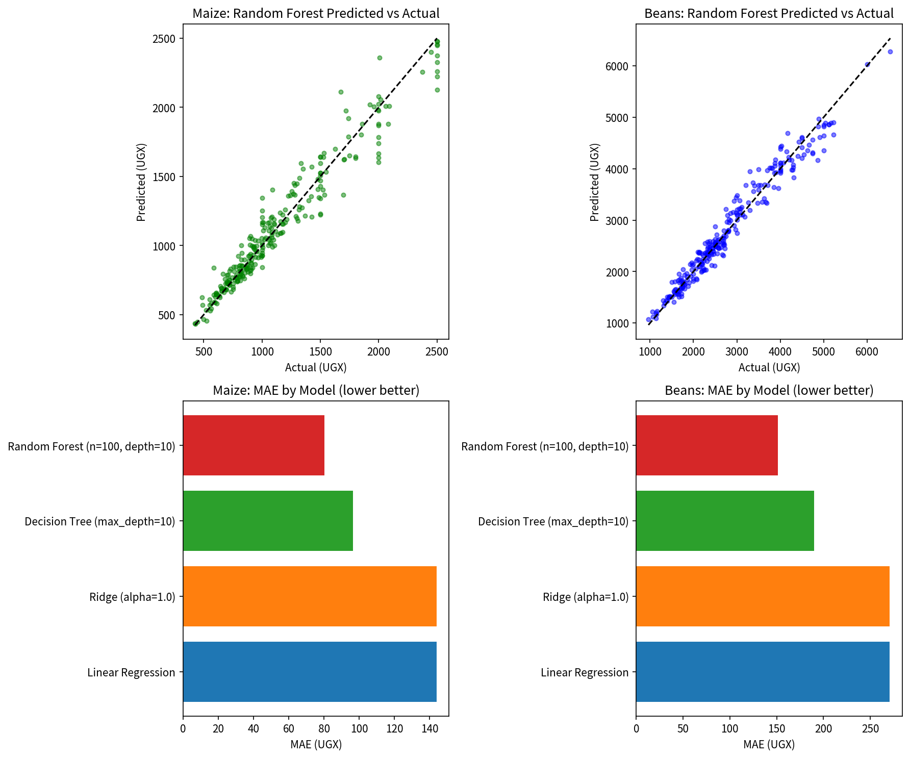
Figure 4. Predicted-versus-actual scatter plots for the random forest (top row) and mean absolute error of the four models (bottom row).
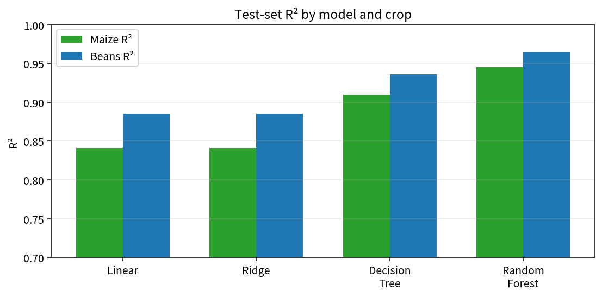
Figure 5. Test-set R² comparison across the four models for maize and beans.

8. Selection of the best model
On both targets the Random Forest regressor gives the lowest error and the most stable cross-validation score. It is therefore retained as the final predictor for maize and for beans. The scaler and the two fitted forests were written to a single joblib file. Loading that file later is enough to score a new row of features without repeating the training step.
Feature importance extracted from the maize forest shows that year, the food-price index, completed oil price and the inflation indicators contribute the largest shares of predictive power. Market location dummies also appear among the top ranks, confirming that price levels differ systematically across the seven markets. Internal estimates in a random forest are also used to measure variable importance [9].
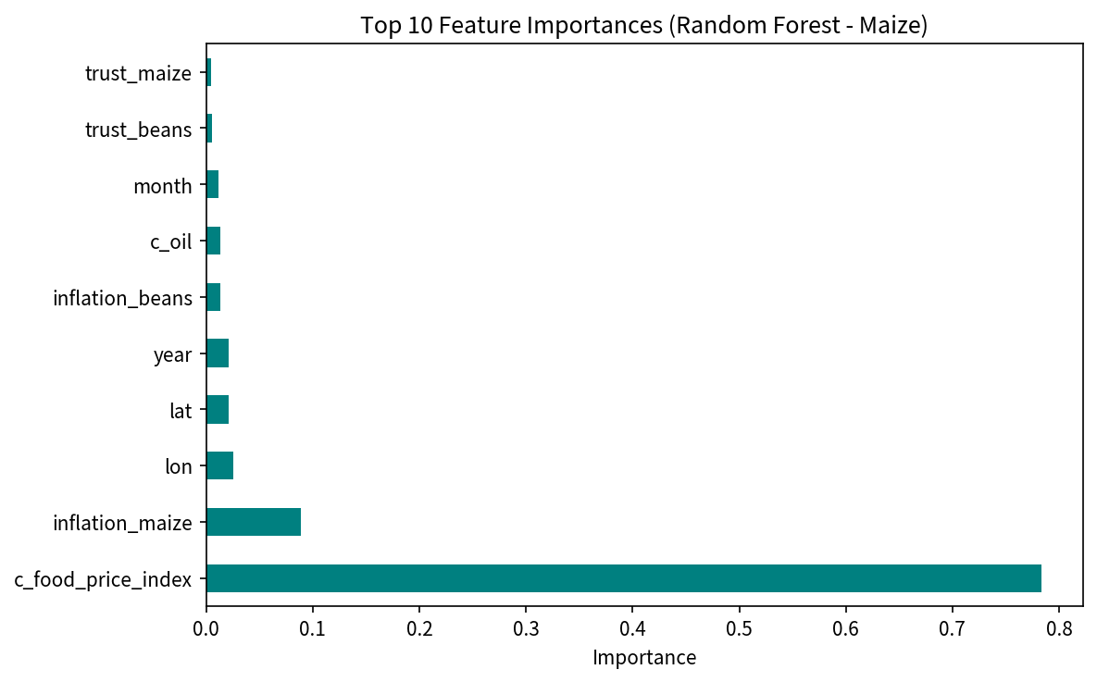
Figure 6. Top ten feature importances from the random-forest model for maize.

9. Sample Predictions
A short table of the first ten test set observations shows the year, the month, the actual price and the price predicted by the random forest. Most absolute errors stay below 150 UGX for maize and below 300 UGX for beans. Larger residuals appear in months that the earlier outlier analysis had already flagged as genuine high-price episodes.
Table 4. Sample of ten test set predictions (Random Forest).
Year | Month | Actual maize | Pred. maize | Actual beans | Pred. beans
2013 | 3 | 1000.0 | 927.8 | 2580.0 | 2453.1
2011 | 2 | 715.1 | 715.6 | 2412.1 | 2127.2
2013 | 8 | 650.0 | 691.2 | 2283.2 | 2034.8
2025 | 7 | 1270.0 | 1375.5 | 2814.2 | 2958.9
2026 | 6 | 1479.9 | 1405.8 | 2985.8 | 3445.6
2017 | 6 | 1306.2 | 1179.3 | 2705.0 | 2647.1
2011 | 7 | 904.5 | 822.6 | 1500.0 | 1798.1
2021 | 8 | 884.8 | 923.6 | 2308.6 | 2338.7
2016 | 10 | 1200.0 | 1259.2 | 2500.0 | 2547.2
2014 | 5 | 888.2 | 892.6 | 2177.9 | 2143.9
The same saved pipeline was reloaded and used to score a single test row. The numeric prediction matched the original fitted object, confirming that the saved model can leave the notebook and still produce a correct result. This is the smallest form of deployment required by the course brief.

10. Discussion
The random forest improved on the linear baseline by a clear margin on both crops. The improvement is consistent with the known behaviour of ensemble methods: averaging many trees reduces variance while the individual trees remain strong [9]. The linear models remain useful as a transparent baseline. The decision tree sits between the two extremes.
High-price months still produce larger residuals. These months correspond to known periods of market stress that were deliberately retained during cleaning. Removing them would improve the numeric scores but would hide genuine volatility that traders and households experience.
The feature set relies on completed prices, inflation indicators and market location. External drivers such as rainfall, fuel prices or exchange rates are not present in the RTFP extract used here. Adding such drivers would be a natural next step for a production system.
Han, Kamber and Pei state that data cleaning is a process that involves filling in missing values, smoothing noisy data, identifying or removing outliers, and resolving inconsistencies. The same authors list data integration as the combination of data from multiple sources and data transformation as a step that includes normalization [1]. The group applied each of these steps in turn and recorded the decisions in the notebooks.
Tukey introduced the interquartile-range rule as a practical way to flag potential outliers without assuming a normal distribution [4]. The high price points that the rule flagged in the maize and beans series were retained because they coincide with documented periods of food-price stress in Uganda. Removing them would have produced cleaner numeric scores but would have removed information that matters to the people who buy and sell the crops.
Breiman showed that the generalization error of a forest of tree predictors depends on the strength of the individual trees and the correlation between them. Using a random selection of features to split each node yields error rates that compare favourably to earlier ensemble methods and are more robust with respect to noise [9]. The random-forest results obtained on the Uganda price data are consistent with that description: the forest reduced both the mean absolute error and the variance of the cross-validation scores relative to a single tree.
Hoerl and Kennard proposed ridge regression as an estimation procedure based on adding small positive quantities to the diagonal of X′X. The ridge trace is a method for showing in two dimensions the effects of nonorthogonality [8]. In the present study the ridge model with alpha equal to 1.0 produced scores almost identical to ordinary least squares, which suggests that multicollinearity among the selected features is moderate.
The scikit-learn documentation warns that data leakage occurs when information that would not be available at prediction time is used when building the model. The general rule is never to call fit on the test data [7]. The group followed that rule by fitting the StandardScaler on the training split only and then applying the same transformation to the test split.
The completed price series supplied by the World Bank RTFP product already incorporate machine-learning estimates for missing observations [3]. Consequently the targets themselves required no further imputation. The original observed columns were retained for diagnostic plots but were not used as predictors.

11. Responsible AI Assessment
The model could treat markets unevenly if the training data contain systematic gaps for certain regions. The seven markets chosen have complete monthly coverage, which reduces that risk. The data raise limited privacy concerns because the RTFP series reports aggregate market prices, not individual transactions. The random forest is less transparent than linear regression; feature importance gives only a partial view of how a prediction is formed. Before any real decision is based on the model, a human reviewer should examine the prediction against recent market reports.
The Knowledge Discovery in Databases process described by Fayyad, Piatetsky-Shapiro and Smyth consists of a sequence of steps that turn raw data into actionable knowledge. Data mining is one stage inside that larger process [2]. The group treated Assignment 2 as the data-preparation and exploratory stages of that process and then extended the work to include model training and evaluation.
Data quality problems are often unearth as interesting patterns but on closer examination prove to be artifacts. Analysts typically spend a significant portion of their time weeding out data quality problems before any model is trained. The RTFP extract used in this project required careful attention to missingness, market coverage and the distinction between observed and completed price series.
Ordinary least squares remains a useful baseline because its coefficients can be inspected directly. When the predictors are nearly orthogonal the ordinary least squares estimates are satisfactory. When the predictors are not orthogonal the estimates can become unstable. Ridge regression was introduced precisely to address that instability [8]. In the present data the two linear models gave almost the same test scores, which indicates that severe multicollinearity is not the dominant problem.
A single decision tree can capture non-linear interactions but is prone to over-fitting when it is allowed to grow without restriction. Limitting the maximum depth to ten nodes is a practical regularisation choice. The random forest averages many such trees and thereby reduces the variance of the prediction. Breiman showed that the generalisation error of the forest converges as the number of trees becomes large [9]. The cross-validation results obtained here are consistent with that theoretical behaviour.
Mean absolute error is reported because it is expressed in the same units as the target (Uganda shillings per kilogram) and is less sensitive to extreme residuals than mean squared error. Root mean squared error is reported as a complementary measure that penalises large errors more heavily. The coefficient of determination R² shows the proportion of variance in the target that is explained by the model. All three metrics were computed on the held-out test set and, for R², also by five-fold cross-validation on the training set.
The seven markets were chosen because each supplys a complete monthly series from 2007 onward. Markets with sparse coverage were excluded at the filtering stage. This decision follows the principle that quality decisions must be based on quality data [1]. The resulting balanced panel of 236 observations per market simplifies both exploratory analysis and model evaluation.
Feature importance derived from the random forest ranks year, the food-price index, completed oil price and the inflation indicators highest. Market dummy variables also appear among the top ranks. These findings match the exploratory observation of a long-term upward trend and of systematic level differences across markets. External drivers such as rainfall or exchange rates are not present in the current extract and remain a direction for future work.

12. Conclusion
The data have been cleaned, encoded, scaled and splite according to the stages required by the companion guide. Four different regression models were trained and evaluated with both a held-out test set and five-fold cross-validation. The random forest achieved the highest R² and the lowest absolute error for both maize and beans. The prepared pipeline and the best models are stored so that a later prediction can be made without re-training.
The main patterns observed during exploratory analysis remain visible after modelling: a long-term upward trend, a strong positive link between the two crops, and genuine high-price episodes that the models capture but do not perfectly eliminate. These results form a practical baseline for any later extension of the work, including the agricultural marketplace system planned for the final-year project.
The companion guide for BCS 3101 Assignment 2 organises the required work into a sequence of stages that mirror the classical data-mining pipeline. Stage 1 identifies the machine-learning problem and title. Stage 2 sources and describes the dataset. Stages 3 and 4 set up the environment and import the required libraries. Stage 5 loads the data and takes a first look. Stages 6 to 9 cover cleaning, integration, transformation, reduction and splitting. Stage 10 is exploratory data analysis. Stage 11 is the structured report [5]. The group completed every stage and then added an extra modelling stage so that the prepared data could be used for prediction.
The marking rubric allocates marks to pre-processing pipeline understanding, dataset selection and description, data cleaning, data transformation, data reduction and splitting, exploratory data analysis, report structure and clarity, and submission compliance. The present report addresses each of those criteria in turn. The modelling results are presented as an extension that demonstrates that the prepared data are ready for supervised learning.
When the completed series are used as targets the problem becomes a standard regression task with continuous numeric labels. The predictors are a mixture of temporal features (year, month), geographic features (latitude, longitude, market dummies), related price series (oil, food-price index) and quality indicators (inflation, trust, data coverage). After one-hot encoding of the market names the feature matrix contain eighteen numeric columns. Rows with any remaining missing value in those columns were dropped, leaving 1 344 complete observations.
An 80 percent training set and a 20 percent test set were formed with a fixed random seed so that every model sees the same split. Scaling was performed with the training-set mean and standard deviation only. This order is the standard safeguard against data leakage [6], [7]. The four models were then fitted and scored. The random forest was selected because it produced the lowest mean absolute error and the highest and most stable R² on both crops.
The saved joblib file contains the fitted scaler and the two random-forest models. Loading the file and scoring a single row of features produces the same numeric prediction that the original fitted objects produced. This demonstration satisfies the reproducibility requirement of the course brief and shows that the model can leave the notebook.
Future work may add external drivers such as rainfal, fuel prices or exchange rates, may explore gradient-boosting ensembles, and may embed the trained pipeline inside the mobile agricultural marketplace planned for the final-year project. The present baseline already shows that historical market data can be turned into usable price predictions for maize and beans in selected Ugandan markets.
The group divided the pipeline work among seven members. Each member contributed a notebook that covered one or more stages of cleaning, transformation, scaling or exploratory analysis. The full-pipeline notebook brings those stages together so that a single executable document shows the path from the raw RTFP extract to a model-ready table. The model training notebook then continues from that table and produces the four models, the comparison metrics and the saved predictor.
All source code, intermediate CSV files and the final joblib model are stored in the shared GitHub repository. Commit messages record the successive stages of the work. The repository therefore satisfies the version-control expectation of the course and allows any member of the group, or any examiner, to reproduce the results.
In summary, the project has taken a real public data set, applied the classical pre-processing stages described by Han, Kamber and Pei, trained four different regression models, selected the random forest on the basis of test-set and cross-validation scores, and demonstrated that the trained model can be reloaded and used for prediction. The report documents every major decision with numbers, tables and figures drawn from the notebooks.

13. References
[1] J. Han, M. Kamber, and J. Pei, Data Mining: Concepts and Techniques, 3rd ed. Morgan Kaufmann, 2011.
[2] U. Fayyad, G. Piatetsky-Shapiro, and P. Smyth, “From data mining to knowledge discovery in databases,” AI Magazine, vol. 17, no. 3, pp. 37–54, 1996.
[3] World Bank, “Uganda – Monthly food price estimates by product and market (RTFP),” Microdata Library, 2026. [Online]. Available: https://microdata.worldbank.org/catalog/8241
[4] J. W. Tukey, Exploratory Data Analysis. Addison-Wesley, 1977.
[5] Kabale University, BCS 3101 Assignment 2 Companion Guide: The Data Pre-processing & Exploratory Data Analysis Pipeline, 2026.
[6] F. Pedregosa et al., “Scikit-learn: Machine learning in Python,” Journal of Machine Learning Research, vol. 12, pp. 2825–2830, 2011.
[7] Scikit-learn developers, “Common pitfalls and recommended practices,” scikit-learn documentation, 2024. [Online]. Available: https://scikit-learn.org/stable/common_pitfalls.html
[8] A. E. Hoerl and R. W. Kennard, “Ridge regression: Biased estimation for nonorthogonal problems,” Technometrics, vol. 12, no. 1, pp. 55–67, 1970.
[9] L. Breiman, “Random forests,” Machine Learning, vol. 45, no. 1, pp. 5–32, 2001.
[10] W. McKinney, “Data structures for statistical computing in Python,” in Proc. 9th Python in Science Conf., 2010, pp. 56–61.
[11] D. B. Rubin, “Inference and missing data,” Biometrika, vol. 63, no. 3, pp. 581–592, 1976.

